2.0 cm
Beef cattle stocking rate, a key to the conservation of the pastoral system in Brazilian biomes

Urbano Abreu, Embrapa Pantanal, urbano.abreu@embrapa.br
Célia Grego, Embrapa Monitoramento por Satélite, celia.grego@embrapa.br
Maria Fasiaben, Embrapa Informática Agropecuária, maria.fasiaben@embrapa.br
Eliane Gomes, Embrapa Sede, eliane.gomes@embrapa.br
Maxwell Almeida, IBGE, Coordenação de Agropecuária, maxwell.almeida@ibge.gov.br
Octávio Oliveira, IBGE, Coordenação de Agropecuária, octavio.oliveira@ibge.gov.br

ABSTRACT
In Brazil, beef cattle are raised in predominantly extensive systems. The feeding base is represented by native and/or cultivated pastures. The latter may be in a well conserved state or may present some degree of degradation. The amount of animals per hectare, supported by the pasture by each time unit, is basically related to the pasture production. There is interaction between quality and production, and changes in these parameters are strongly affected by the stocking rate. Therefore, the adjustment in the stocking rate is the most important management factor and the main determinant of animal production and pasture composition. Municipal data from the 2006 agriculture and cattle raising business census were considered with the objective to analyze, by means of typologies, the use of pastoral areas in Brazil. In the census, the producers declared their pastoral areas according to the following classification: native pasture areas (PN), cultivated pasture areas in good conservation status (PC) and cultivated pasture areas with some degree of degradation (PCD). They also indicated the number of bovine in each type of pasture. The data were submitted to exploratory factorial analysis, with varimax rotation. The first two factors (extracted by main components) explained 0.83 of the (co)variance, and the estimate of the Kaiser-Mayer-Olkin (KMO) adequacy test was 0.76, which meant good adjustment of the variables selected. The commonalities of the variables selected, PN area; total pasture area (TP), bovines in PN (Bov_PN); bovines in PCD area (Bov_PCD); bovines in PC area (Bov_PC); bovines in total pasture area (Bov_APT); and the stocking rate (TxLota) were 0.65; 0.97; 0.77; 0.74; 0.79; 0.87; and 0.99, respectively. The first factor was associated with the variables PN, TP, Bov_PN, Bov_PCD, Bov_PC, and Bov_APT, which directs to the latent variable correlated to those municipalities with large pasture areas, in general, and also with the largest cattle population. The variable TxLota presented the most significant factorial load in the second factor, that is, all those municipalities with the greatest concentration of cattle per unit area are represented in the second factor. The municipalities that were best represented in factor_1 are different from the ones represented in factor_2. The non-parametric correlation between the classifications of the two groups of municipalities formed by the factorial scores in the first and the second factors is small (0,24). This indicates that the context of those municipalities with the highest stocking rate is a lot different from the ones with the largest areas and cattle herds. The application of livestock development policies in the different Brazilian biomes should take into account all the distinguishing features of the municipalities, regarding their context, especially the pasture areas and their vocation for primary livestock production.

Keywords: Multivariate analysis; Typology; Land use

- Introduction

The livestock production system is composed of a series of technologies and management practices, the type of the animal, the purpose of the breeding, the breed or racial group, and the eco-region where the activity is developed (Euclides Filho, 2000). In Brazil, in the production of beef cattle, the extensive systems are prevalent in grazing regime, with native and/or cultivated pastures, encompassing three distinct phases: cow-calf, rearing and fattening. The cow-calf phase includes calves until weaning age and bulls, cows and heifers at mating age. The rearing phase starts with weaning and ends when females reach breeding age and males reach the development required for fattening. Fattening is the final stage of slaughter and usually lasts one year.
The extensive production system in Brazil has been criticized for a long time, due to low productivity. It is economically viable mainly due to the expansion of the grazing areas. The activity is traditionally pioneer, since it is able to occupy significant areas of land very quickly, with the application of low capital in the production process. However, Martha Jr. et al. (2012), by means of the analysis of productivity gains in four time periods, found that in the most recent period of 1996-2006, the productivity gain of the activity was very significant (6.64% per year). They concluded that the largest part of the technological changes in the Brazilian beef cattle production occurred in the recent past.
The stocking rate (number of animals per unit area) reflects the grazing supportability, that is, it is the pressure of use that allows the balance between the gain per animal per unit area, which maximizes the revenue. The forage availability determines the stocking rate and controls simultaneously both the quality and the quantity of pastures, and consequently enables the plants to remain productive and, in parallel, defines the animal production. It is thus important to consider the interaction of forage availability and the livestock production at the decision-making in relation to the stocking rate adjustment (Euclides, 2001). The use of a constant stocking rate all year round is the simplest and the most used method. A single stocking rate is defined and what is subgrazed during the rainy season remains to be used during the dry season.
The animal performance is directly affected by the stocking rate, that is, the stocking rate is a control variable, while productivity per animal is a response variable. The magnitude of the effect is modulated by different variables that interact dynamically. The current context of limitation of the activity expansion, by means of the opening of new areas to the detriment of the native vegetation, because of Government control and the growing pressure from society, strengthens the continuous need to incorporate new technologies to the production systems (Barioni et al., 2008).

The optimal grazing intensity is considered as the appropriate point of use of the pastures, which allows an optimal livestock production, without jeopardizing the balance between the species that make up the pasture. According to Mott (1960), there is a critical point of forage availability that represents the smallest amount of forage that may keep both the maximum consumption and the animal performance. The gain per animal is constant, with an increased stocking rate up to the critical point. In addition, the gain per animal is inversely related to the stocking rate.
In parallel, it is necessary to analyze, in the different municipalities of Brazilian biomes, the characteristics of the beef cattle production systems, by means of categorizations (typologies) based on the most important variables that make up the systems, by taking into account the diversity of the elements and their interrelationships.
In livestock systems, the construction of typologies is the effective method for conducting syntheses that may facilitate the understanding of the complex nature of the systems, which supports the decision maker in the promotion of livestock development policies. This paper aims to analyze how beef cattle use pastoralist areas in Brazil, by means of building typologies.

- Material and Methods

  - Survey data

In 2007, IBGE carried out a census operation that included the 2006 Agriculture and Livestock Census, the 2007 Population Count and the National Registry of Addresses for Statistical Purposes – CNEFE. The joint operation aimed to update the population estimates and the information on the economic activities developed in the country, both by individuals and by agribusiness companies.
The Agriculture and Livestock Census is a large-scale statistical operation performed periodically in order to collect, process and disseminate data about the structure of the agriculture, livestock, forestry and aquaculture sectors in the country. The typical structural data are: size of the agriculture exploitation, use of the land, cultivated areas, irrigation, livestock population, labor, and other agriculture and livestock inputs. They are directly collected in all agriculture and livestock establishments. Among the several variables, the 2006 Census of Agriculture investigated the agriculture and livestock establishments and activities, including detailed information about the characteristics of the producer, the characteristics of the establishment, the economy and the employment in rural, livestock, farming and the agribusiness industry areas. The data collection started in April 2007, by means of direct interviews with the people responsible for the agricultural and livestock establishments.
In this paper, the agriculture and livestock census data were filtered to specialized properties in beef cattle. The database was established with the variables related to pasture, and the cattle population in each pasture type and situation. The variables and their definitions are presented below.
Natural pasture (PN): natural fields, and others – these are the areas (in hectares) of unplanted pastures, even those areas that were subjected to cleaning, disk harrow or others, used or intended for the grazing of the existing animals in the establishment;

Planted pasture that was degraded (PCD) due to inadequate management or lack of conservation, which was found degraded or little productive – this included the areas that were planted with vegetation species intended for the grazing of the existing animals in the establishment and that exhibited this condition;

Planted pasture in good condition (PC) – this refers to the areas that were planted or prepared to be planted with vegetation species intended for the grazing of the existing animals in the establishment. They were not degraded as they received frequent maintenance. The pastures in process of recovery were included here; and

Total area of pasture (PT) – this corresponds to the sum of all areas described above.

The cattle population count was based on declaratory information, including the cattle that belonged to the producer, the employees and the residents who were in the establishment on the reference date. The producer's cattle were in transit, in transfer pens, in common or open pastures located outside the agriculture and livestock establishment, in another agriculture and livestock establishment under grazing or rental regime, or in units that provided confinement service. The cattle that belonged to more than one producer were registered in the questionnaire referring to the establishment where they were on the reference date. The cattle belonging to third parties were leased, rented or assigned to the producer. The count did not include the producer’s animals that were rented or assigned to third parties, located in other establishments on the reference date.

  - Statistical analysis

Data from 4,904 municipalities from all Brazilian states were assessed. Different multivariate techniques were employed for the analysis and the classification of the municipalities according to the stocking rate, in order to develop the type. Firstly, the basic statistics were estimated by biome and by state. After the critical analysis, the exploratory factor analysis was conducted in order to evaluate the behavior of a large number of variables related to the stocking rate, by means of a small amount of latent factors. Data from the areas of PN, PCD, PC, and PT. In addition to the number of cattle in native pasture (Bov_PN), cattle in degraded cultivated pasture (Bov_PCD), cattle in cultivated pasture (Bov_PC), cattle in total pasture area (PT) and cattle stocking rate (TxLota).
As the data are highly correlated, the factorial analysis was applied. It is a technique that helps explain the behavior of a large number of variables in relation to a small amount of factors (common underlying dimensions), because many ratios between the variables are due to the same general causal factor. The essential purpose of the factor analysis is to describe the (co)variance between the different indicators, by means of unobservable random linear combinations (latent variables) called factors (Johnson & Wichern, 1999).
The eingevalue above one of each factor was the criterion used to select the number of factors. The extraction of factors was performed by means of the main components method. For a more efficient analysis of the results, the varimax rotation was carried out. Two factors were kept. The factors were then submitted to the technique of grouping analysis, by means of Ward’s minimum variance method. Ten groups of municipalities were formed. The methodologies used are described by Khattree & Naik (2000). The SAS statistical package was used to carry out the analysis.

- Results and Discussion

Figure 1 shows the averages and standard deviations of the stocking rates in the six Brazilian biomes. The lowest grazing pressure with the lowest stocking rate is the Pantanal, an expected result due to the very extensive production system of beef cattle carried out in the region (Abreu et al., 2010). On the other hand, the Mata Atlântica has the largest number of cattle heads per hectare. This is probably due to a more intensive land use in rural properties, with smaller areas and a larger number of cattle on pasture.

Amaz – Amazonas, Caa - Caatinga, Cerr - Cerrado, Mata - Mata Atlântica, Pam - Pampa, Panta – Pantanal.

Figure 1. Average stocking rate (number of cattle heads per hectare) in each Brazilian biome.

The first two factors (extracted by main components) explained 0.83 of the (co)variance, and the estimate of the Kaiser-Mayer-Olkin (KMO) adequacy test was 0.76, which meant good adjustment of the variables selected. The values of commonalities, which are the efficiency measures of the representation of each indicator by a common part, also involved in the variables selected, PN area; total area of pasture (TP); cattle in PN (Bov_PN); cattle in the area of PCD (Bov_PCD); cattle in the area of PC (Bov_PC); cattle in total area of pastures (Bov_APT); and stocking rate (TxLota) were 0.65; 0.97; 0.77; 0.74; 0.79; 0.87; and 0.99, respectively.
The first factor was associated with the variables PN, TP, Bov_PCD, Bov_PC, Bov_PN, and Bov_APT, which directs to the latent variable correlated with those municipalities with large areas of pasture, in general, and also with the largest cattle populations. The variable TxLota presented the most significant factorial load in the second factor, that is, all those municipalities with the highest concentration of cattle heads per unit area are represented in the second factor.
The municipalities that were best represented in factor_1 are different from the ones represented in factor_2. The non-parametric correlation between the two groups of municipalities formed by the factorial scores in the first and the second factors is small (0.24). This indicates that the context of those municipalities with the highest stocking rate is a lot different from the ones with the largest areas and cattle herds.
Table 1 exhibits the averages of the land use indicators in beef cattle pastoral farming directed to the stocking rate of each group defined by means of the cluster analysis.

Table 1. Number of municipalities in each cluster and the averages of the areas (in hectares) in municipal scale of each variable analyzed.
Clusters | N | PN | TP | Bov_PN | Bov_PCD | bov_ATP | Tx_ATP
I | 1210 | 3,851.26 | 7,724.83 | 3,314.73 | 3,671.59 | 5,368.99 | 0.74
II | 946 | 1,906.82 | 7,195.52 | 3,833.13 | 8,838.31 | 11,841.12 | 1.68
III | 1412 | 4,724.98 | 12,397.77 | 6,163.96 | 9,302.29 | 12,610.79 | 1.19
IV | 737 | 973.69 | 3,901.13 | 2,712.40 | 6,394.28 | 8,592.34 | 2.40
V | 136 | 212.12 | 425.99 | 1,048.48 | 983.12 | 1,751.68 | 4.77
VI | 293 | 17,380.82 | 78,024.65 | 25,682.67 | 80,937.66 | 95,224.49 | 1.29
VII | 143 | 25,125.20 | 218,256.87 | 64,331.27 | 205,006.87 | 235,733.69 | 1.12
VIII | 13 | 81.24 | 311.14 | 503.77 | 3,130.08 | 3,490.08 | 10.10
IX | 13 | 253,279.67 | 709,817.92 | 249,499.31 | 543,000.31 | 644,890.00 | 0.95
X | 1 | 2,905,728.72 | 3,634,382.60 | 1,568,139.00 | 1,203,516.00 | 1,704,523.00 | 0.47
N- numbers of municipalities, PN - natural pasture, TP – total area of pasture, Bov_PN – bovines in natural pasture area, Bov_PCD- bovines in cultivated pasture areas with some degree of degradation, Bov_APT - bovines in total area of pasture, and the stocking rate (TxLota).

Some indicators of socioeconomic nature help in the characterization of the clusters and are shown in Table 2.
According to Table 2, clusters 1 to 5 are characterized by the greatest weight of crop production in the income of the agricultural and livestock establishments, compared with the production of beef cattle, both regarding the total value of the production and the revenue obtained from sales. In clusters of 6 to 10, the situation is reversed, and the beef cattle are responsible for the highest percentage of the income of the establishments.
Analyzing Cluster 1 in more detail, with 1,210 municipalities, there is a distribution throughout the national territory, with greater concentrations in the Northeast region and in the state of Minas Gerais. All biomes have at least one representative in the cluster, but the Caatinga and the Cerrado stand out. In the municipalities in this cluster, the crop production has greater weight than beef cattle, in relation to the total value of production and the revenue from the sale of the products by the establishments. Here, the crop production represents, on average, 62% of the total revenue of the establishments, while beef cattle production represents approximately 29%. The income of the producer and their family (which refers to pensions, retirements, Government aid, etc.), added to the non-agricultural income obtained by the establishments, account for about 10% of the total revenue. In this cluster, 32% of the establishments are classified as family establishments. The percentage of establishments with cattle herds tracked down is the lowest among all clusters (just over 3%). On the other hand, the ratio between investment in new pastures and the total of the financing taken by agricultural and livestock establishments reaches about 27%, on average. In Figure 2 we see the spatialization of the municipalities belonging to Cluster 1.

Table 2 – Characterization of the clusters according to socioeconomic indicators (in percentage).
Clusters  INDICATOR | I | II | III | IV | V | VI | VII | VIII | IX | X
Participation of cattle herds in the value of total production | 31,1 | 30,9 | 32,5 | 32,4 | 22,6 | 62,1 | 64,6 | 74,1 | 85,0 | 99,4
Participation of crop production in the value of total production | 62,9 | 50,0 | 60,4 | 54,7 | 50,7 | 33,4 | 30,7 | 15,7 | 12,8 | 0,1
Participation of cattle herds in the total of revenues | 29,4 | 30,3 | 31,6 | 31,1 | 22,4 | 61,5 | 64,2 | 75,3 | 83,5 | 98,7
Participation of crop production in the total of revenues | 61,9 | 47,8 | 58,2 | 53,4 | 50,0 | 31,3 | 29,0 | 14,3 | 11,9 | 0,0
Participation of cattle herds in the total revenue of the agriculture and livestock activity | 30,6 | 35,8 | 33,0 | 33,0 | 26,7 | 64,2 | 66,3 | 81,2 | 86,0 | 99,6
Participation of crops production in the total revenue of the agriculture and livestock activity | 64,3 | 56,4 | 60,7 | 56,7 | 59,6 | 32,7 | 29,9 | 15,4 | 12,2 | 0,0
Participation of the producer and their family’s income in the total of revenues¹ | 7,7 | 4,0 | 5,7 | 4,4 | 2,8 | 6,7 | 4,9 | 15,7 | 5,5 | 1,7
Participation of other non-agricultural incomes in the total of revenues² | 1,8 | 0,6 | 1,9 | 0,7 | 0,7 | 1,1 | 0,9 | 0,1 | 0,5 | 0,2
Percentage of family establishments | 32,1 | 33,9 | 34,9 | 47,9 | 43,2 | 43,8 | 37,2 | 30,8 | 33,6 | 6,3
Percentage of establishments with their cattle herds tracked down | 3,4 | 9,6 | 6,5 | 6,6 | 4,5 | 11,4 | 20,4 | 14,1 | 22,7 | 25,2
Ratio between investments in new pastures and total financing | 26,9 | 7,8 | 27,2 | 14,5 | 1,3 | 27,4 | 25,1 | 0,6 | 41,5 | 21,7
Source: 2006 Agriculture and Livestock Census (IBGE, 2006a)
Notes:
¹Incomes from the producer and their family include, among the most important items: Retirement or pension; Paid activities developed by the producer outside the establishment; Revenue from donations or voluntary aid; Revenue from governmental social programs (federal, state or municipal); Divestments (IBGE, 2006b). ²Other non-agricultural activities carried out in the establishment – total value obtained in 2006 with non-agricultural activities carried out in the premises or in the area of the establishment, such as sale of handicrafts, weavings, etc., produced in the establishment in 2006 (IBGE, 2006b).

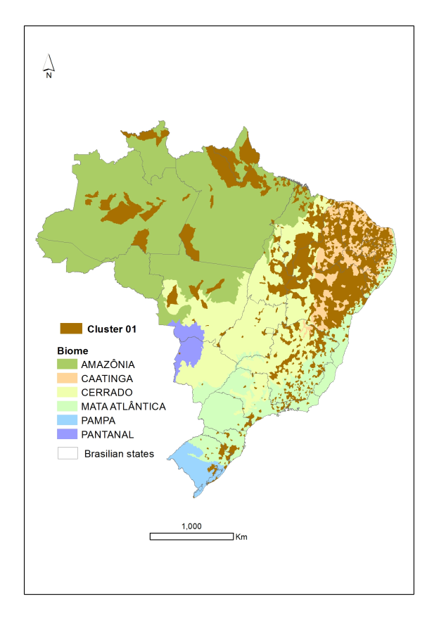
Figure 2 – Spatialization of the municipalities in Cluster 1.

Cluster 2 includes 946 municipalities, concentrated in the Southeast and the South regions, with representatives in the other regions, covering the entire range of the Mata Atlântica in the northeast. The municipalities may be observed in Figure 3. With the exception of the Pantanal, all the biomes are included in this cluster, but the prevalence is Mata Atlântica. In the municipalities in Cluster 2, the agricultural and livestock establishments also get most of the income from crop production. The participation of the beef cattle in the total revenue of the establishments is just over 30%, on average, while the crop production represents 48% of the total revenue. The external revenues (income from the producer and their family), added to other non-agricultural income of the establishment, make up close to 5% of the total revenue. The percentage of family establishments is 34%, and almost 10% of establishments claimed to have cattle herds tracked down. The investments in new pastures, compared to the total of agricultural and livestock financing, represent just under 8%.

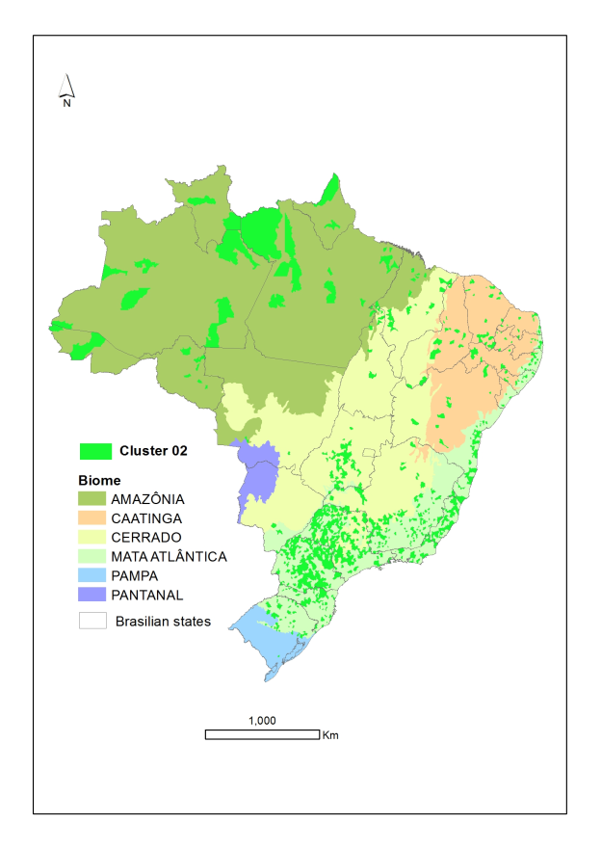
Figure 3 – Spatialization of the municipalities belonging to Cluster 2.

Cluster 3 spreads throughout all regions of the country and comprises 1,412 municipalities. All biomes are represented in Cluster 3, except the Pantanal (Figure 4). Crop production is the most important source of revenue of the establishments in this group, accounting for 58% of the total revenue, while beef cattle production accounts for almost 32%. The external revenues and the non-agricultural revenues reach near 8% of the total revenue of the establishments. The family establishments represent 35% of the total. The ratio between investments in new pastures and the total funding is 27%, and 6.5% of the establishments reported having their cattle herds tracked down.
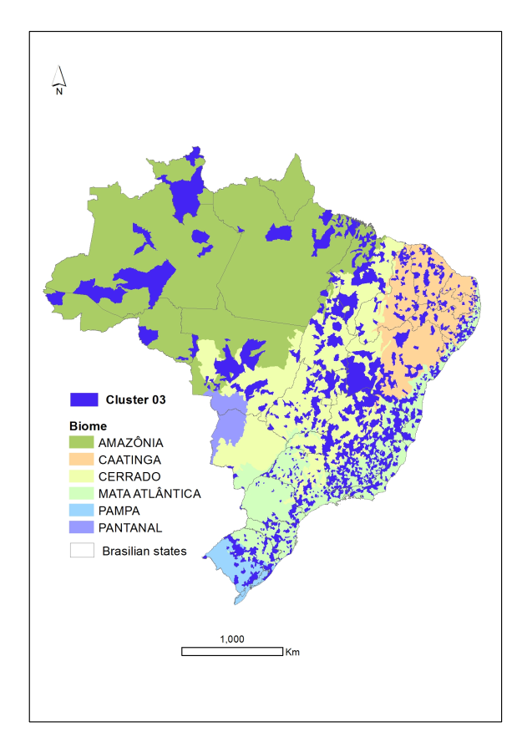
Figure 4 – Spatialization of the municipalities belonging to Cluster 3.

Cluster 4 includes 737 municipalities, mainly located in the states of Parana, west of Santa Catarina and north of Rio Grande do Sul, besides the North region of the country. The only biome that is not represented in the cluster is the Pantanal. Most municipalities are located in the Mata Atlântica (Figure 5).
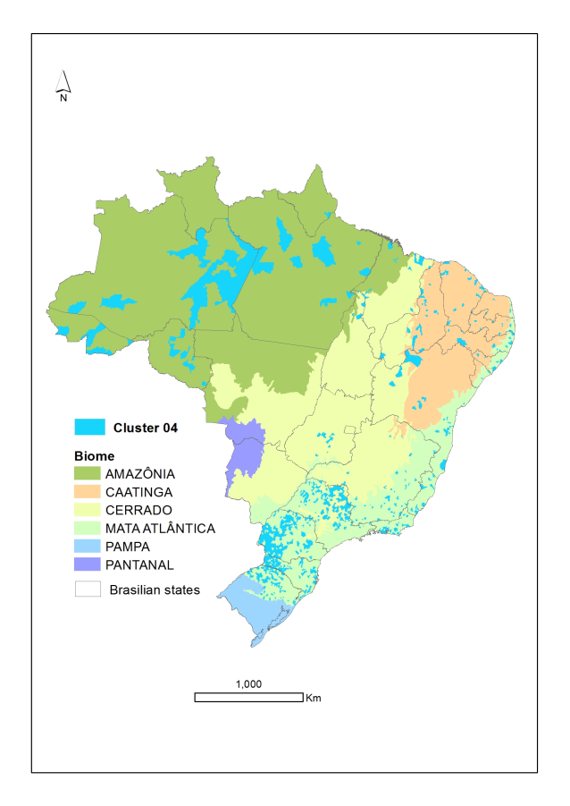
Figure 5 – Spatialization of the municipalities belonging to Cluster 4.
The crop production corresponds to 53% of the total revenue of the establishments, while the beef cattle herds account for 3%. The sum of the producer and their family’s income and other non-agricultural income account for 5% of the total revenue earned by the establishments. The family establishments are 48% of the total (the highest value among all clusters). Only 6.6% of the establishments declared having their cattle herds tracked down, and the ratio between investments in new pastures and the total financing is 14.5%.
Cluster 5 (136 municipalities) does not depict a clearly defined distribution standard. No municipality in the Pantanal biome is included here. The crop production represents 50%, on average, of the total revenue of the establishments, whereas the cattle herds is close to 22%. The income of the producer and their family, plus the non-agricultural income obtained in the establishments respond for 3,5% of the total revenue. Here, 43% are family establishments. The percentage of establishments with cattle herds tracked down is 4.5%. The investments in new pastures in relation to financing taken by the establishments represent 1.3%.
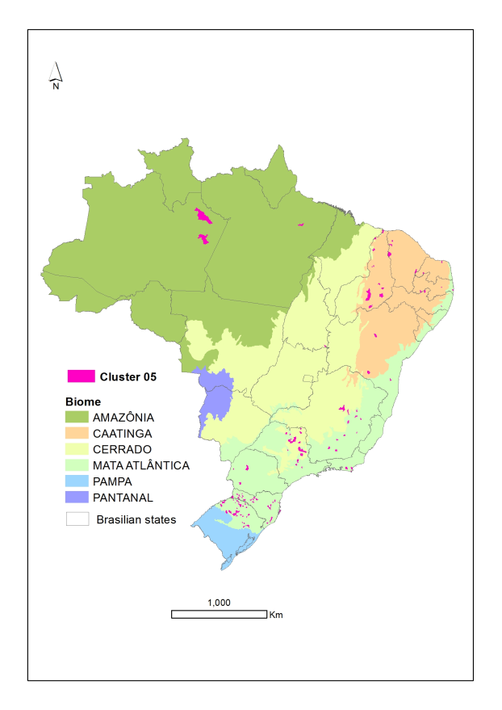
Figure 6 – Spatialization of the municipalities belonging to Cluster 5.

Cluster 6 includes 293 municipalities, mainly located in the North, Central-west, Southeast regions and in the south of Rio Grande do Sul. Although all the biomes have at least one representative in the cluster, the highest concentration of municipalities is in the Amazônia, Cerrado and Pampa biomes. In this cluster, the participation of the beef cattle production in the total revenue of the establishments is close to 62%, while the participation of the crop production falls to 31%. The income of the producer and their family, plus the non-agricultural income represents almost 8% of the total revenue. The family establishments account for 44% of the total of agricultural and livestock establishments. Over 11% of the establishments declared to have their cattle herds tracked down. The ratio investments in new pastures/total financing is 27.4%. The spatialization is shown in Figure 7.

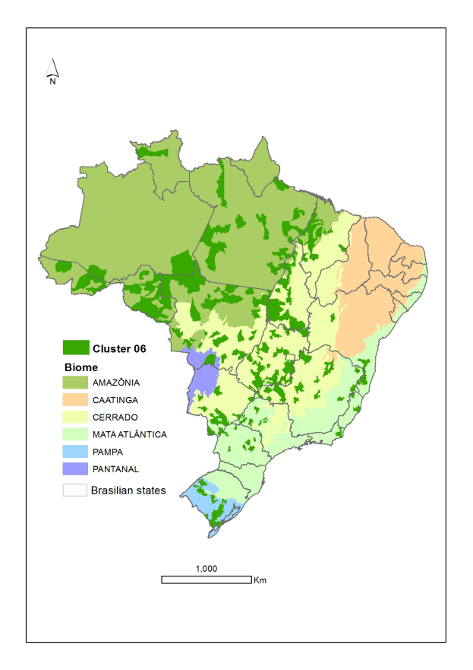
Figure 7 – Spatialization of the municipalities belonging to Cluster 6.

Cluster 7, with 143 municipalities, also presents a concentration in the North and Central-west regions, north of Rio Grande do Sul and Minas Gerais (Figure 8). The municipalities in this cluster are located in the Amazônia, Cerrado, Pampa and Pantanal biomes. Here, the participation of beef cattle production in the establishments revenue is over 64% and the crop production corresponds to 29%. The revenue of the producer and their family, added to the non-agricultural income, are almost 6% of the total revenue. From the total, 37% are family establishments. In 20% of the establishments the cattle herds are tracked down. The ratio between investments in new pastures and the total revenue is 25%.

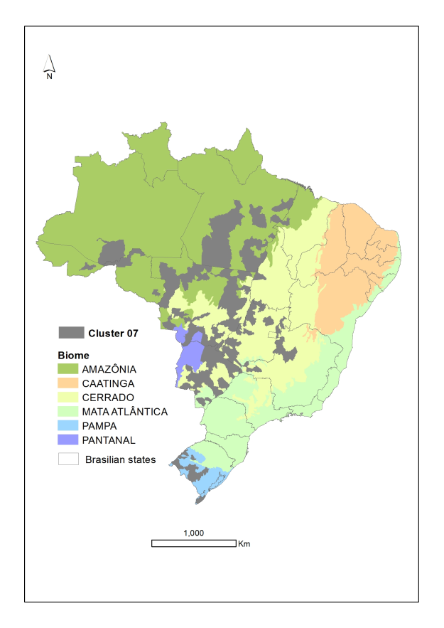
Figure 8 – Spatialization of the municipalities belonging to Cluster 7.

Cluster 8 is related to 13 municipalities, distributed within different regions in the country, except for the Northeast. They are located in the Mata Atlântica, Cerrado and Amazônia biomes. The crop production corresponds, on average, to 14% of the total revenue if the establishments, whereas the beef cattle production accounts for 75%. The sum of the producer and their family’s income and the non-agricultural profits, on average, is over 15% of the revenue of the establishments. The family establishments are around 31% of the total. In 14% of the establishments the cattle herds are tracked down. The ration between investments in new pastures and the total financing is only 0.6% (Figure 9).
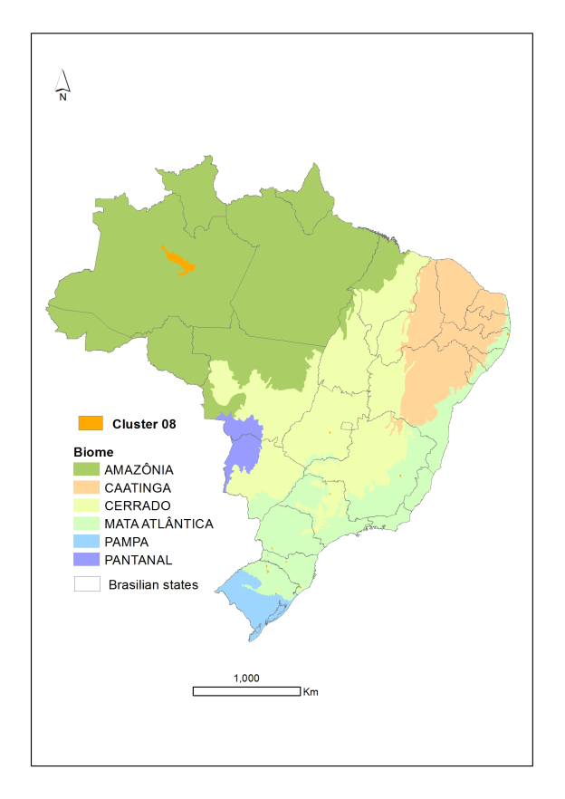
Figure 9 – Spatialization of the municipalities belonging to Cluster 8.

The 13 municipalities in Cluster 9 are distributed within the North and Central-west regions and in the south of Rio Grande do Sul. They relate to the Amazônia, Cerrado, Pantanal and Pampa biomes. The beef cattle production corresponds to 83% of the total revenue of the establishments, whereas the crop production accounts for only 12%. The sum related to the producer and their family’s income and the non-agricultural profits is 6% of the total revenue. The family establishments represent 33% of the total. In around 23% of the establishments the cattle herds are tracked down. The ratio investments in new pastures/total financing is 41.5%, the highest among all clusters (Figure 10).

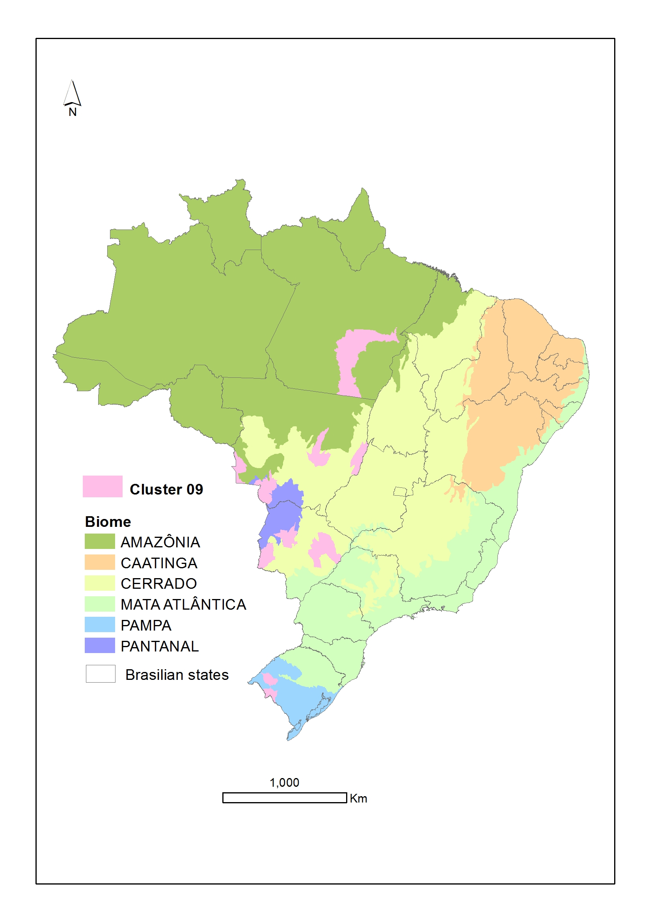
Figure 10 – Spatialization of the municipalities belonging to Cluster 9.

Cluster 10 is represented by only one municipality (Corumbá-MS), which is located in the Pantanal. In the municipality, the beef cattle production accounts for almost the total of the establishments’ revenue (98.7%). The remaining revenue is completed with external revenue. Only 6.3% were classified as family establishments. From the total, 25% declared to have their cattle herds tracked down. The ratio investments in new pastures/total financing is 21.7%.

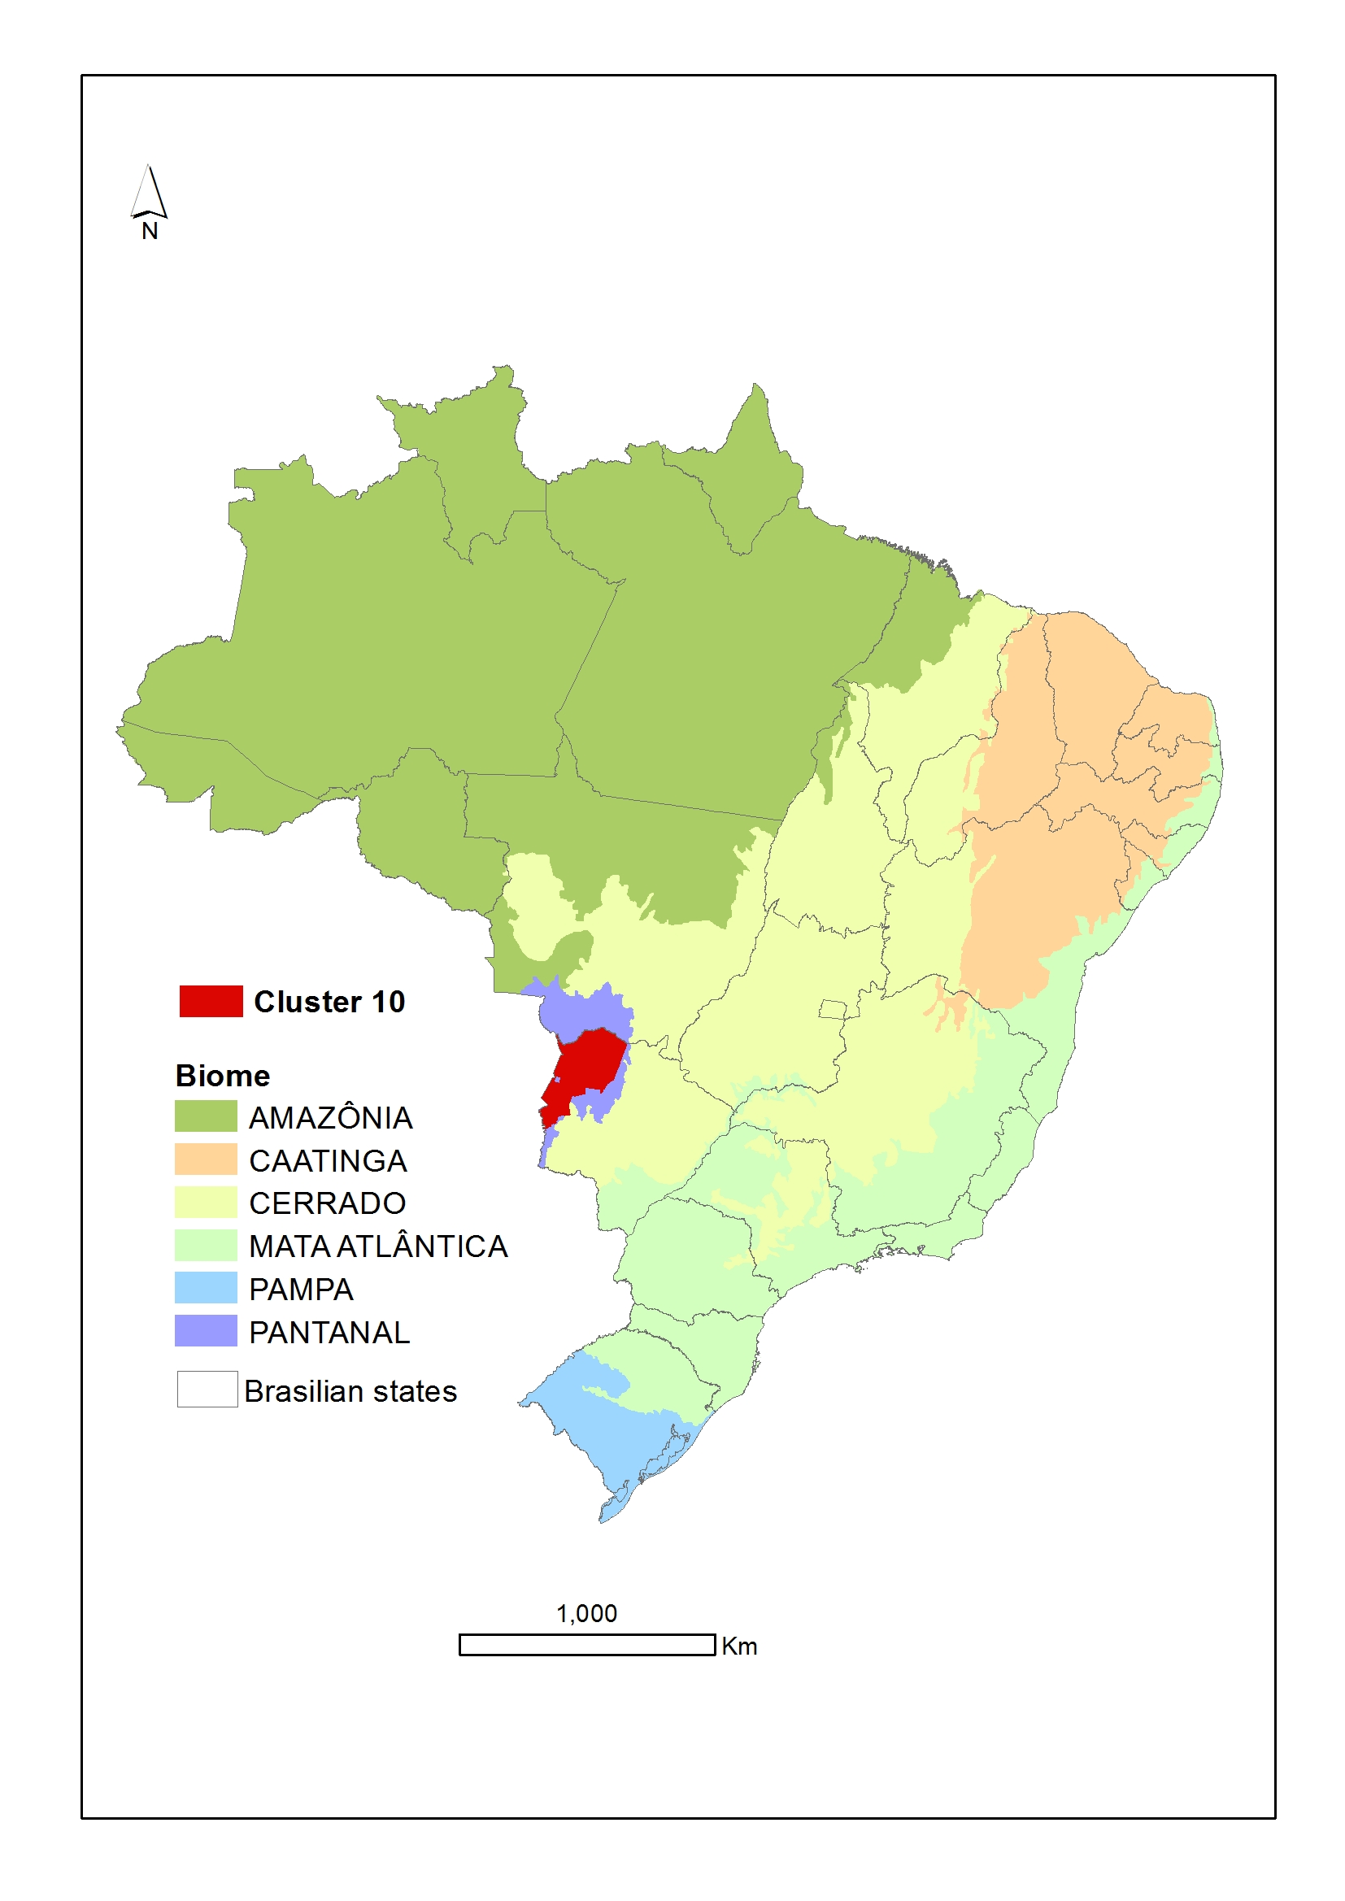
Figure 11 – Spatialization of the municipalities belonging to Cluster 10.

- Conclusion

The preparation of livestock development policies in the different Brazilian biomes should consider the distinguishing features of the municipalities, regarding their context, especially the pasture areas and their vocation for primary livestock production.

- References

Abreu, U.G.P.; McManus, C.; Santos, S.A. (2010) Cattle ranching, conservation and transhumance in Brazilian Pantanal. Pastoralism - Research, Policy and Practice, 1, 99-114.

Barioni, L. G.; Tonato, F.; Martha Jr, G. B.; Lupinacci, A. V.; Veloso, R. F. (2008) Visão sistêmica aplicada à otimização da produtividade do animal e da área, in: VI Simpósio de Produção de Gado de Corte, Valadares Filho, S.C., Paulino, M. F., Paulino, P. V. R., Figueiredo, F.C., Barros, L. V., Diniz, L. L., Marcondes, M. I., Chizzotti, M. L., Fonseca, M.A., Benedeti, P. D. B., (Eds), Suprema, 6 321-344.

Euclides, V. P. B. (2001) Produção intensiva de carne bovina em pasto, in: II Simpósio de Produção de Gado de Corte, Bittencourt, A., Ferreira, C.C.B., Figueiredo, F.C., Magalhães, K.A., Guimarães, J.D., Paulino, M.F., Valadares Filho, S.C. (Eds), Suprema, 2 55-82.

Euclides Filho, K (2001) Interação genótipo-ambiente-mercado na produção de carne bovina nos trópicos, in: II Simpósio de Produção de Gado de Corte, Bittencourt, A., Ferreira, C.C.B., Figueiredo, F.C., Magalhães, K.A., Guimarães, J.D., Paulino, M.F., Valadares Filho, S.C. (Eds), Suprema, 2 93-115.

IBGE. Instituto Brasileiro de Geografia e Estatística. Censo Agropecuário 2006. 2006a. Disponível em: <http://www.sidra.ibge.gov.br>. Vários acessos.

IBGE. Instituto Brasileiro de Geografia e Estatística. Censo Agropecuário 2006: Manual do Recenseador. Rio de Janeiro. 2006b. Disponível em:
<http://biblioteca.ibge.gov.br/visualizacao/instrumentos_de_coleta/doc1131.pdf >. Acesso em 21 jun 2013.

Johnson, R.A.; Wichern, D.W. (1999) Applied multivariate statistical analysis. Upper Saddle River: Prentice-Hall, 816p.

Khattree, R; Naik. D.N. (2000) Multivariate data reduction and discrimination with SAS software. Cary: SAS Institute Inc., 558p.

Martha Jr, G. B.; Alves, E.; Contini, E. (2012) Land-saving approaches and beef production growth in Brazil. Agricultural Systems, 110, 173-177.
Mott, G. O. (1960) Grazing pressure and the measure of pasture production, In: International Grassland Congress, 8, Reading, Proceedings..., 606-611.

This indicator aims to compare the expenditure in new pastures among the several clusters, but the investments in pastures do not necessarily use exclusively external financing.

