Use of swine waste-derived biogas for the enhancement of microalgae productivity

J.M. Prandini¹, M.L.B. Da Silva², M. P.Mezzari³, H. M. Soares¹

¹ Federal University of Santa Catarina - UFSC, Florianópolis, SC, Brasil
(E-mail: jeanprandini@hotmail.com)
² Embrapa Swine and Poultry, Concordia, SC, Brasil
³ West University of Santa Catarina, UNOESC, Videira, SC, Brasil

HIGHLIGHTS
Biogas from swine wastewater digestion was used in a closed photobioreactor to stimulate microalgae growth. Biogas enhanced microalgae growth rate by up to 3 fold as compared to atmospheric CO₂. Despite improving microalgae biomass growth, a significant removal of undesirable CO₂ and H₂S from biogas was achieved.

Keywords
Biofiltration; CO₂; microalgae; H₂S; swine wastewater.

INTRODUCTION
In recent years, great attention has been given to the cultivation of microalgae, largely because of its potential as feedstock for biofuel production, mitigation of CO₂ emissions and removal of nutrients from wastewaters. The proliferation of microalgae in swine wastewater’s tertiary treatment systems can aid to the removal of N and P, which are nutrients that can pose a risk of contamination and eutrophication of water bodies. The rate of nutrients consumption by microalgae is somewhat limited to the amount of atmospheric CO₂ (0.04 % v/v) [1]. Therefore, it may be possible to utilize the biogas produced upstream from the tertiary treatment systems not only to increment microalgae productivity, but also to accelerate the rate of nutrients removal. The objective of this work was to verify the effects of swine wastewater-derived biogas on the growth rate of microalga Chlorella sp. in a lab scale photobioreactor. The usefulness of microalgae cultivation to remove CO₂ and H₂S from the biogas was also evaluated which can have implications as biofilters.

MATERIALS AND METHODS
Microalgae were cultivated in a closed photobioreactor using a transparent polyethylene type bag under continuous stirring and mixotrophic conditions (photoperiod of 12 h). The photobioreactor was kept at room temperature (23°C) and exposed to red LED light (630 nm; 148.5 μmol m⁻² s⁻¹). The growth medium was prepared by dilution of digestate effluent (5% v/v). The biogas composition was: CH₄ (≈72.7% v/v); CO₂ (≈21.2% v/v); H₂S (≈3.000 ppmv). Two experimental conditions were established: microalgae growth from the first 0 to 96h of experiment (phase 1) and from 160 to 215h (phase 2). Between the two phases, the photobioreactor was kept in contact with atmospheric air and without biogas. Microalgae dry weight biomass was determined gravimetrically and the initial biomass concentration was 38.07 mg L⁻¹. At phase 1, approximately 63% v/v of pure biogas was added in the closed photobioreactor headspace. In phase 2 (from 160 to 215h of experiment) the initial microalgae biomass measured was 332 mg L⁻¹ with 80% v/v biogas volume. CO₂, H₂S and CH₄ were measured directly from the closed photobioreactor headspace (GEM 5000-LANDTEC). The polyethylene bag was filled with water only and served as negative control to discern abiotic gas reactions such as dissolution, precipitation and leaks.

RESULTS AND DISCUSSION
The microalgae specific growth rate obtained in the absence of biogas was 0.07 d⁻¹ (Figure 1). In the presence of biogas, microalgae specific growth rates increased to 0.6 (d⁻¹) in phase 1 and 0.2 (d⁻¹) in phase 2. Interestingly, the lower growth rate observed in phase 2 could be linked to the limiting availability of nutrients [2] and light deficiency due to shading effects from the increased microalgae biomass [3]. Nonetheless, microalgae specific growth rate from phase 2 was superior 3× higher and in agreement with the results reported by Chiu et al. [3], where microalgae growth rates of 0.6 (d⁻¹) and 0.25 (d⁻¹) were observed when bubbling with CO₂ or atmospheric air, respectively.
Microalgae CO₂ consumption (normalized from abiotic losses from control experiments) was 4.1% and 6.4% in phases 1 and 2, respectively. The increase in microalgae biomass occurred concomitantly with the reduction in CO₂ concentrations and reached a plateau once CO₂ was no longer available. Thus, it is plausible to assume that a superior growth could be achieved with continuous injection of CO₂ even in the absence of additional supply of nutrients in the culturing medium.
CH₄ concentration remained mostly constant throughout the experimental time frame with a small decrease of 0.9% v/v and 1.4% v/v in phase 1 and 2, respectively. H₂S was quickly and completely removed (100% removal efficiency) during both experimental phases. Removal of H₂S was mostly linked to the oxidative characteristics of the culturing media which is rich in O₂-derived photosynthesis. Although not studied in this work, microbial mediated biological H₂S removal is also possible by chemiolitotrophic bacteria that oxidize H₂S to sulfate.

CONCLUSION
The removal of nutrients from digestate downgrading from anaerobic digesters can be achieved by microalgae proliferation. Biogas from swine wastewater digestion stimulated microalgae growth by almost 3 fold. It is anticipated that the larger biomass can contribute to faster nutrient uptake from wastewater ultimately leading to cleaner effluents in shorter hydraulic retention times. Additionally, undesirable gases invariably present in biogas (CO₂ and H₂S) are also removed, which boosts the usefulness and value of biomethane as a sustainable source of biofuel.
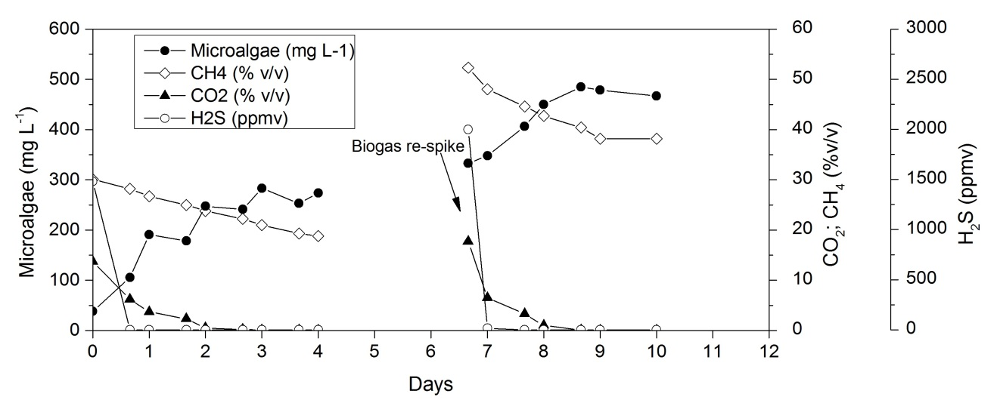
Figure 1: Variation of microalgae concentration (mg L⁻¹), CO₂ (% v/v), CH₄ (% v/v) and H₂S (ppmv) during 10 days of cultivation.

REFERENCES
[1] Kumar, A., et al, 2010. Enhanced CO₂ fixation and biofuel production via microalgae: recent developments and future directions. Trends in biotechnology, 28(7), 371-380.
[2] Cheng, J., et al, 2013. Improving CO₂ fixation efficiency by optimizing Chlorella PY-ZU1 culture conditions in sequential bioreactors. Bioresour Technol. 144, 321-7.
[3] Chiu, S.Y, et al, 2008. Reduction of CO₂ by a high-density culture of Chlorella sp. in a semicontinuous photobioreactor. Bioresour. Technol. 99, 3389–3396.

